MAINTANANCE

Mr. KURIHO

[COMPUTER MAINTANANCE]

[GROUP 10]

**TABLE OF CONTENT**

**COVER PAGE: …………………………………………………………………………………………………………………… (i)**

**TABLE OF CONTENT: ………………………………………………………………………………………………………… (1)**

**GROUP NAMES: …............................................................................................................... (1)**

**DEVICE SPECIFICATIONS :…………………………………………………………………………………………………..( 2)**

**TOOLS USED :……………………………………………………………………………………………………………………..( 3)**

**IDENTIFICATION OF THE PROBLEM :………………………………..………………………………………………….( 5)**

**SOLUTIONS USED :………………………………………………………………………………………………………………( 7)**

**FEEDBACK AND RESPONSE :………………………………………………………………………………………..……….( 7)**

**REFERENCE PAGE :………………………………………….…………………………………………………………………..( 8)**

**GROUP MEMBERS**

|  |  |  |
| --- | --- | --- |
| 1. | ANIYA OMARY SAID | 14233024/T.23 |
| 2. | LAMECK GODWIN ATHANAS | 14233057/T.23 |
| 3. | JOYCE ROBERT SANANE | 14233029/T.23 |
| 4. | ALLY AWADHI ALLY | 14233055/T.23 |
| 5. | YATHRIBABDULAZIZ DHULKARNAYN | 14233067/T.23 |
| 6. | AMIRI ATHUMAN AMIRI | 14233049/T.23 |
| 7. | MIKIDADI. I. KASIMBA | 14233066/T.23 |

**DEVICE SPECIFICATIONS**

**IN OUR GROUP, WE WERE DEALING WITH A HP LAPTOP, WHICH HAD A PROBLEM OF NOT SWITHING ON. THE LAPTOP GIVEN TO US HARD THE FOLLOWING SPECIFICATIONS:**

* THE PROCESSOR:

The HP laptop given was consisting of Intel corei4.

* RAM:

The Random Access Memory of laptop was consisting with a four (4) GB RAM of which is much portable to make the laptop to perform its activities faster enough.

* STORAGE :

The laptop was consisting of SSD hard drive of 500GB storage, which provide storage, and increases the fastest move of the computer in terms of storage.

* GRAPHICS:

Most HP laptops comes with integrated Intel HD graphics or dedicated graphics card from NVIDA or AMD for gaming, so the laptop we had was consisting with the Intel HD Graphics cad.

* DISPLAY:

The screen size of the HP laptop we hard was xx inches to xx inches with the resolutions of HD (1920 x 1080).

* OPERATING SYSTEM:

It consist with a window 10 in its OS system.

* THE CONNECTIVITY:

The laptop contains different connective parts such as USB ports, Ethernet port, headphone jack, HDMI, Bluetooth reader and WIFI reader card.

* WEIGHT AND DIMENSIONS:

Most of the laptops comes up with different weight and dimensions of which our group’s laptop given was 1.5kg in weight and the 14x 45cm in dimensions.

**TOOLS USED**

* In our maintenance process, their some tool of which were used to perform the maintenance these tools are like:
* TESTER:

This is one of the device, which we used as a group in performing the maintenance where by this device was used measure if current was entering the laptop.

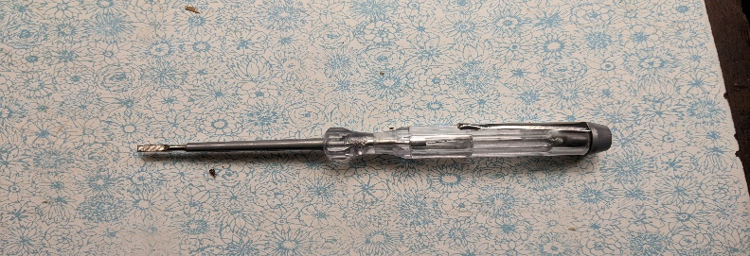

* CREW DRIVER:

A crew driver was use to open all kind of crews which was available on the surface of the laptop and the inertia as well.

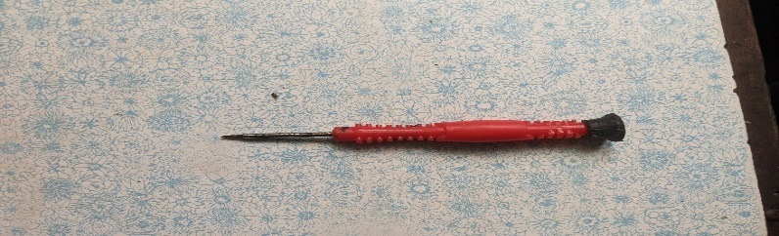

* SPACULAR:

This was device was used to help in the opening process. This helped to catch the ending angles so as opening to be simple.



**IDENTIFICATION OF THE PROBLEM**

* In our group, we were provided with a HP laptop of which was not powering on .so as a group we had to meet together and discuss on the ways how we can overcome or fix this kind of problem. At first we hard to list all causes that can lead the computer to stop supplying power, of which thing like ;
* Low power supply
* This can be led by the shortage in the level of power in the computer.
* Defaults in the battery
* In there the battery can be broken of which cannot power the laptop or it has no ability to store charges due to its duration of time or the faculty default.
* The lithium battery
* The lithium battery it is used to store temporary power to the computer, so sometimes it tends to save all the energy in the laptop making it to fail to power on.
* Bad charger used
* Most of the times us as the users of the computer we tend to use the unrecompensed charger to boost the charging of the computer making the battery to die also the computer as well due to that many chargers are high compared to the original one.
* Failure of some components
* In some cases components be have malfunctioning problem of which is led by either malware or physical damage. The components which when are damage the pc or laptop wont switching on are like; power switch, the screen and battery

**SOLUTIONS USED**

The solution used to fixed the HP laptop given were based on steps which are;

**STEPS:**

1. The first step was to find another charger, which is recommended by the HP Company. Through this, we were checking first if the charger was the problem. However, unfortunately the after changing the charger still the laptop was not powered on this means that the charger is still good.
2. The second we had to open the laptop to see the inner part if there are other problem, after opening we the laptop we had to disconnect the lithium battery to reset the BIOS. After switching on still the problem was not solve.
3. The third step we had to check the power button and we found that it was bit loss so we had to tit it well so as connection can be easily found but still the Laptop could not power on.
4. The fourth step we as a team we had to proceed with removal of the battery, and then we plugged the charger and used direct power from the socket of which the laptop did not switched on.
5. The fifth step we looked at the power button and we found that the wire used to connect the motherboard and the button switch was bit loss of which made the laptop to stop powering on.
6. The sixth step, we try to power on with the direct power from the socket and we found that the laptop had powered on so this marked the first problem to be notice that the problem was the power button.
7. The seventh step, we removed the charger and plugged the battery then we try to power it on using the battery and it powered on , but when we closed it and let it rest for 20mins we tried to power it on and see if it solved the problem but unfortunately it didn’t .
8. In the eighth step, we opened again and removed the battery then we connected the charger direct to the socket and the laptop powered on.
9. In this step, we return the battery then we closed it and the laptop was powered on then was left 30mins running to boost the battery life.
10. After the 30mins we had to do the final last step which is to conduct full diagnostic of the laptop and we found that all components in the laptop are fine including the RAM, Hard drive, processor, Colling fan and other tangible components but we found that the only part which is bring the failure is the battery due to that we received and error dealing with the battery.

**FEEDBACK AND RESPOND**

* As a group we had to reach a conclusion that the problem facing the laptop given to us had two problems, which are the power button, was not connected properly but also the second problem was the battery it is damaged that needs to be replaced so as to ensure the laptop return the state of working properly.

**REFERENCE PAGE**

1. Lecture for Mr. Kuriho(2024)……………………………………………0698101619
2. Lecture from Lunodzo Mwinuka(2018)………………………………….0765268371
3. Chat GPT 3.5 (2024) [Brief description of the conversation or topic]
4. Group members acknowledge2024: